**Sign in to create a Copilot**

Your first task is to sign in so that you can create your copilot.

1. Go to <https://copilotstudio.microsoft.com/> and type in your email that you'll use to build the copilot. Sign in with your work, school, or developer account if you aren't working with an instructor.

**Note**

Your account might already have been set up. If screens similar to the following images don't show, you can skip to step 7.

1. Select **Next**.

[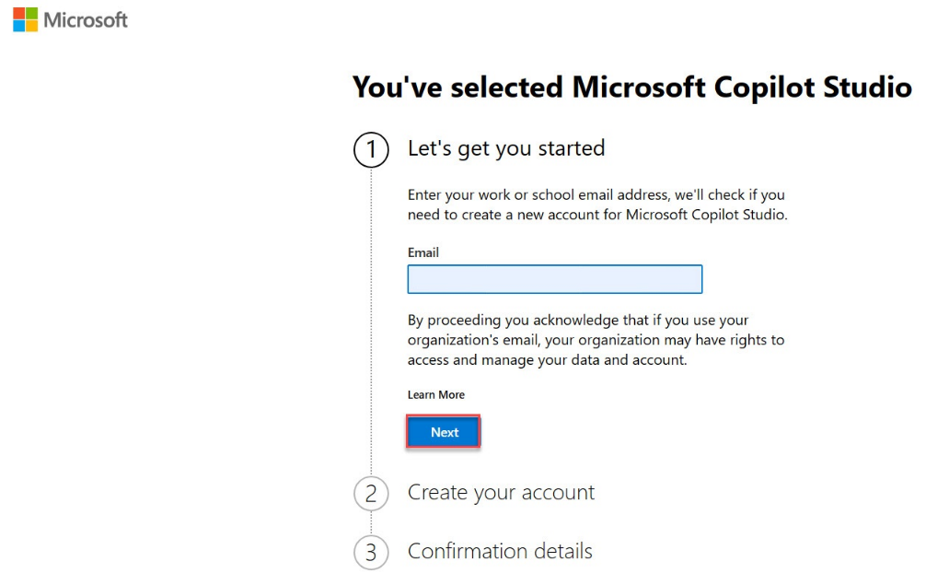](https://learn.microsoft.com/en-us/training/modules/plan-first-chatbot-online-workshop/media/continue.png#lightbox)

1. Select **Get started**.

[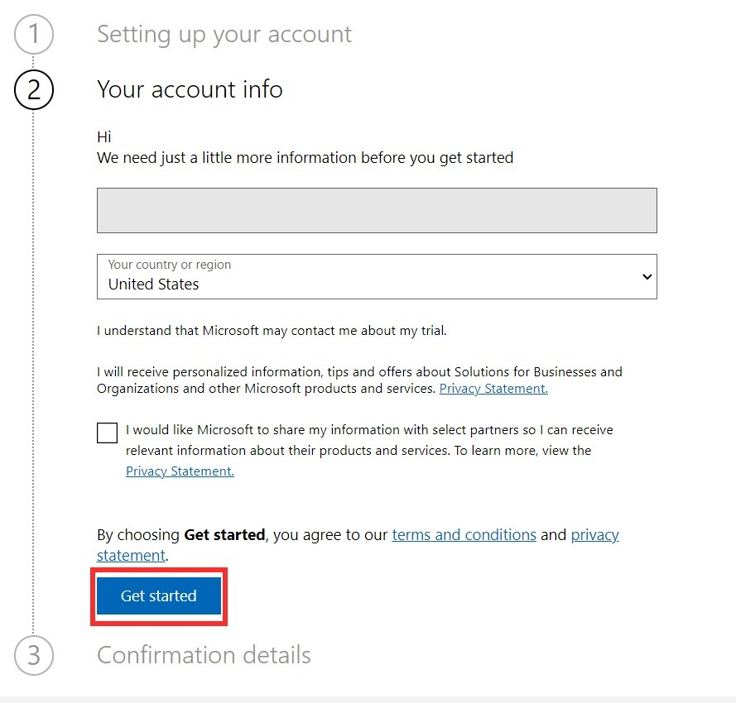](https://learn.microsoft.com/en-us/training/modules/plan-first-chatbot-online-workshop/media/get-started.png#lightbox)

1. Select **Get started** under **Confirmation details**.

[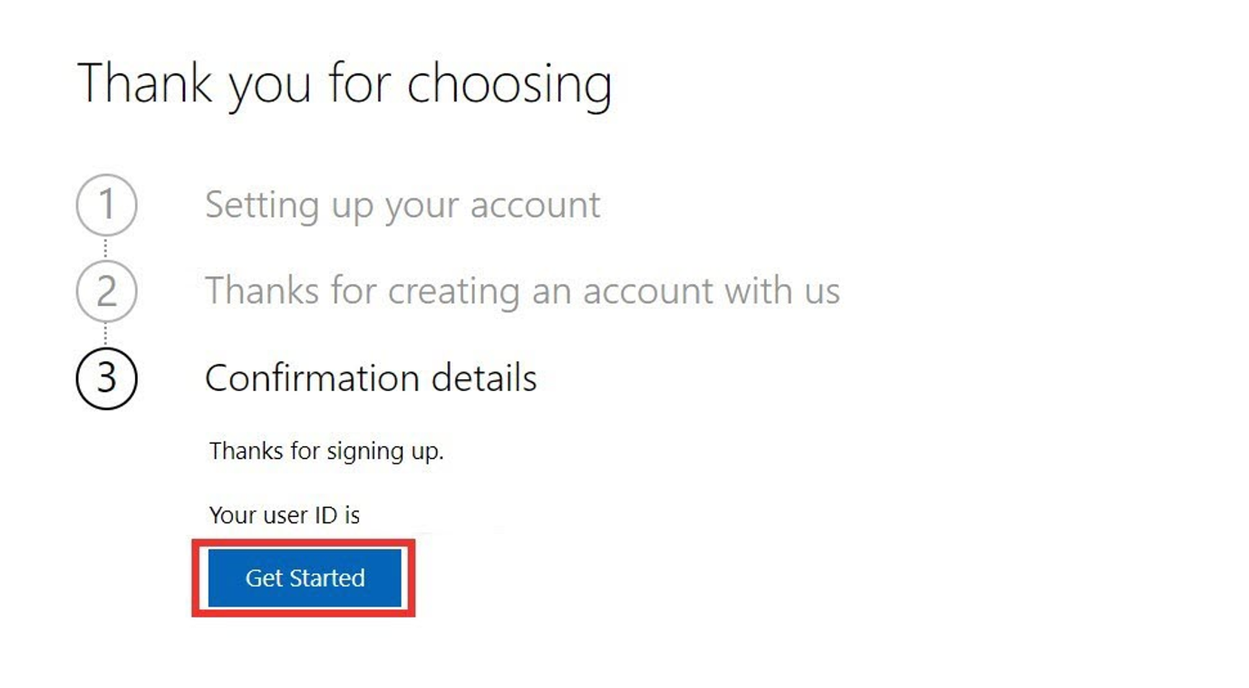](https://learn.microsoft.com/en-us/training/modules/plan-first-chatbot-online-workshop/media/confirmation.png#lightbox)

1. Select your country/region and then select **Start free trial**.

[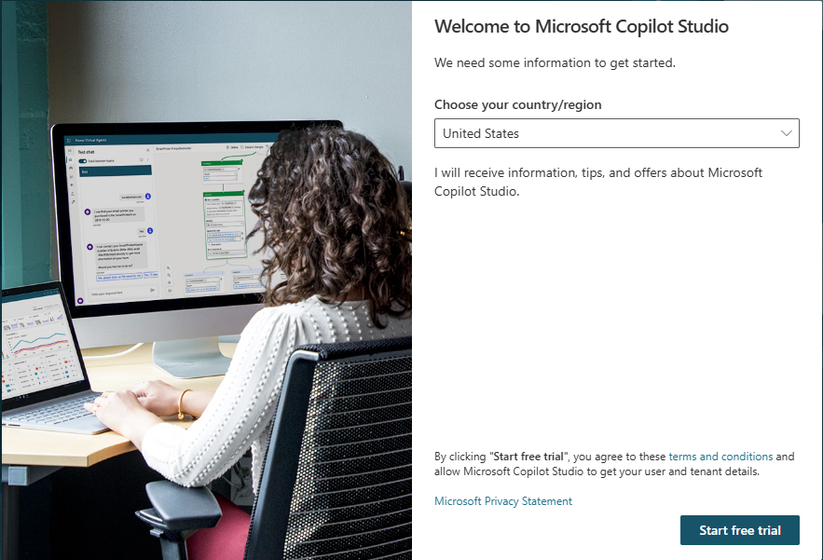](https://learn.microsoft.com/en-us/training/modules/plan-first-chatbot-online-workshop/media/start-free.png#lightbox)

**Important**

Skip to here if your account was already set up.

1. You should be redirected to copilotstudio.microsoft.com. If not, go to the maker environment URL for Microsoft Copilot Studio: copilotstudio.microsoft.com. An **Environment selector** box is located in the upper-right corner. An environment is where your organization stores, manages, and shares the copilot, business data, apps, and Microsoft Power Automate flows. You can select the **Environment selector** button to display the copilots within that environment.

**Create a Copilot**

1. From the Microsoft Copilot Studio **Home** page, **describe** your copilot to create it. Put in a description like the following: I want a copilot named Contoso Customer Service. It's an assistant for Contoso customers, helping to answer questions and help with common tasks like checking an order status.

1. You will get redirected to an optional conversational experience to further customize your copilot. You can provide further details to the description and you can also provide a tone of voice.
2. Start by adding a **tone of voice** to the copilot. Type Playful tone, joyful, customer focus, but definitely professional in the chat box.

1. Next, you'll be asked to provide sources for important information. We'll be using **publicly accessible websites**. Type Information should come from https://learn.microsoft.com/en-us/microsoft-copilot-studio/ and from https://www.microsoft.com/en-us/microsoft-copilot/ in the chat box.
2. You will also get asked for **topics or tasks** the copilot **shouldn’t** help with or talk about. Type We don't want to discuss other brands like Fabrikam. Never provide product comparisons with competitor technologies. in the chat box.
3. In the right side of the window, you'll see a summary pane that displays all the parameters and information you provided to the copilot.

1. Next, above the summary pane, select the ellipses (**...**) and select **Edit advanced settings**.

1. In the **Advanced Settings** window, change the **Schema Name** from the default copilot, to ContosoCustomerService.

1. Finally, select **I'm done** in the chatbox, then select **Create** in the top-right corner.

**Note**

After you've selected **Create**, the process of creating the first copilot within a new environment can take up to 15 minutes. Subsequent copilots are created much faster.

**Note**

After creating the copilot, a pop-up window may appear showing new features in copilot Studio. To continue past this, click **Next** three times and **Done** at the end.

1. After a few minutes, you will be redirected to your copilot's **Overview** page.

After you create your copilot, it appears in the list under the Copilots menu in the left navigation bar.

1. Within the **Copilots** menu, you can select from the copilots that are available to you. Selecting the ellipses next to a copilot brings up drop-down with controls like open the copilot, export the copilot, and delete. You can also select the name of the copilot, which opens it.

**Take a quick tour of the user interface**

Microsoft Copilot Studio makes it easier for you to build basic to advanced copilots. The following section reviews the main pages of the maker experience for Microsoft Copilot Studio.

Because the **Copilot** area was explained in the preceding section, the ensuing section will cover the main options that are available after you select a copilot.

* **Overview** - Displays your home page, including a summary of the copilot's **Details**, **Knowledge**, **Topics**, **Actions**, and **Publish status**.
* **Knowledge** - Allows you to provide a knowledge base as grounding data for your copilot that enables it to pull information from specific data you provide.
* **Topics** - Provides a list of all the **Topics** available to your copilot. These **Topics** are conversation paths you develop to determine how your copilot responds to specific scenarios.
* **Actions** - Allows you to build **Actions** that your copilot can complete. These actions are similar to **Power Automate** flows like automating a database entry.
* **Analytics** - Provides view metrics to monitor how well your copilot is operating. The various **Analytics** sections include: **Customer satisfaction**, **Sessions**, **Billing**, and **Boost conversations**.
* **Channels** - Allows you to publish and connect your copilot with various websites, web-services, and integrations into your own website